What to expect when attending a performance of
Dream Feed
at
HERE Arts Center
The Main Characters In This Show Are:
Justin Hicks
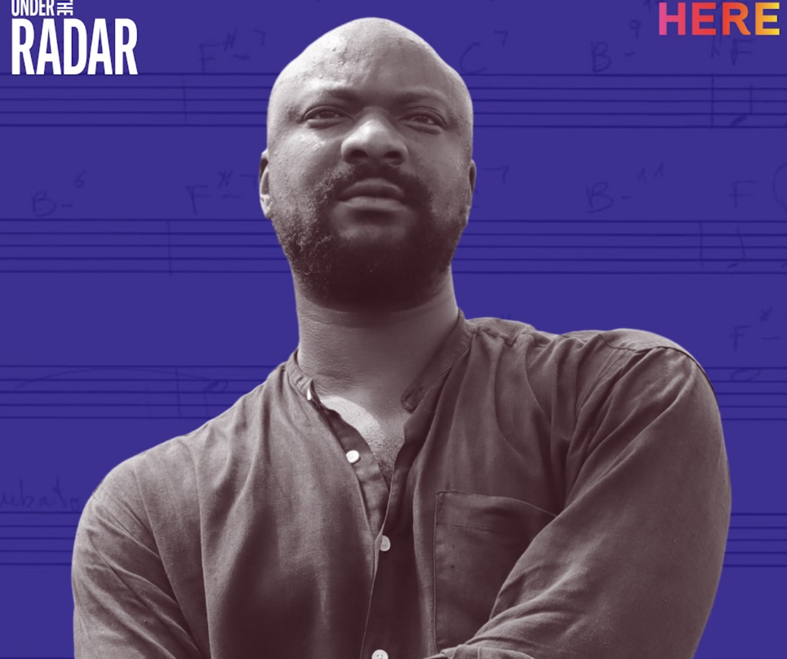
Kenita Miller-Hicks

Jade Hicks


The performers are not playing characters, but simply performing as themselves.

SYNOPSIS:
Dream Feed is a concert which is a series of songs that explore the nature of dreams. The songs are often non-linear, experimental and use imagery to describe how they feel about their dream and what they see in their dreams. The piece does not follow a plot and is not telling a story with a beginning, middle and end. Each song is exploring a different idea about dreams. They use live instruments that they play on stage, recorded music, and a vocabulary of gestures, movement and dance.

MORE ABOUT THE PERFORMANCE:
The run time, or expected length, of this show is 90 minutes.
This show is performed in the round, so audience members will be sitting in a circle surrounding the stage.
This show will take place in the Mainstage Theater at HERE Arts Center.
There will be a limited number of seats reserved for Seats on the Spectrum, indicated by paper signs marked as "reserved." There will be fidget tools available for patron use. They will be located in a container in the lobby, as well as in a container downstairs in the designated break area. Please return the fidget tools to the container after the performance.
Shows use different theatrical elements to help tell the story. In this show, you can expect:
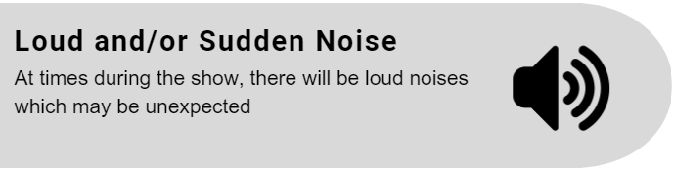
Dream Feed is a concert and the songs change in mood and volume. Towards the end of the performance Kenita Miller-Hicks enters the middle of the performance area after moving the table, and ties instruments onto her legs so that when she stomps and dances, it produces sound.
Be Aware: There are moments with banging of a drum.
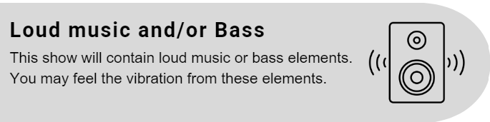
Be Aware: There are song tracks that will start loud and fade out, some moments fade in and up.
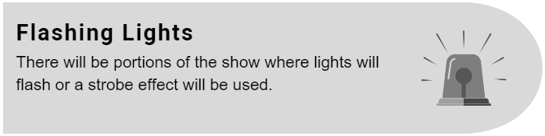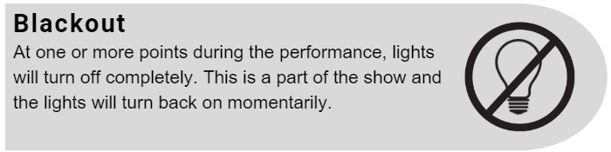
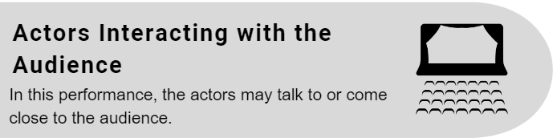
The performers are often facing the audience and singing towards them, as well as making eye contact with audience members. In the last 30 minutes of the show Jade Hicks and Justin Hicks move into the audience where they sit on stools that they bring into the audience and watch as Kenita Miller-Hicks has a solo song in the center of the stage.
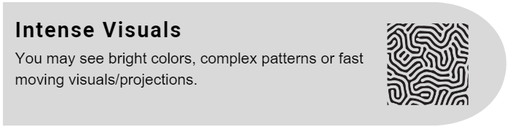
Be Aware: This performance will also use fog and haze.
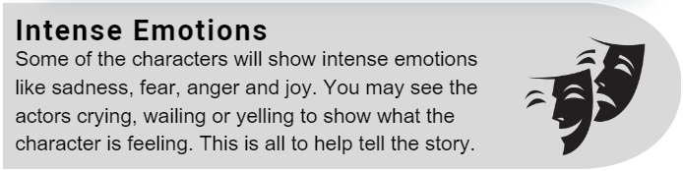
Be Aware: Psychological Distress: The character experiences disorientation, existential crisis, and emotional turmoil. The performers experience dreams, as well ask speaking about dreams that they have had. These dreams include mentions of violence, losing teeth, death and other intense dream experiences.

What To Expect from Your Experience at HERE:
The box office is located in the lobby at HERE Arts Center. Feel free to direct any additional questions not covered by these narratives to the box office staff.
Seating information: All seats are general admission. However, there will be a limited number of seats reserved for SEATS ON THE SPECTRUM, indicated by paper signs marked as "reserved." In order to reserve a SEATS ON THE SPECTRUM ticket, please select your desired ticket price, then select SEATS ON THE SPECTRUM as an add-on at checkout.
There are two all gender bathrooms, one containing only stalls and one with urinals and stalls, located down the stairs and to the left.
Venue information:
The lobby and box office will open two hours before the show starts.
In the lobby area you can also find:
- The box office.
- Couches, tables and chairs to sit.
- A bar with alcoholic and nonalcoholic beverages and snacks available for purchase.
- There will be a house manager present who can answer any questions. They will not be inside of the theater throughout the performance — should patrons need anything during the show, please exit the theater and find the house manager.
The mainstage theater is located on the ground floor. Please alert the box office manager or the house manager should an accessible entrance be needed. For reference, the accessible entrance is located on 6th ave, just around the corner from the main entrance on Dominick St.
Lobby activities:
The red couch downstairs (across from the restrooms) can be utilized as a designated break area. Please note that people will likely pass through the area to use the bathrooms or file in for a show in our downstairs theater.
If there are any questions about these elements of the show or additional information is needed, please contact the box office by calling (212) 647- 0202 or emailing tickets@here.org.

We look forward to seeing you at
Dream Feed


